Developing a Positive Self Image

The Insights and Recommendations of the Foróige Reference Panel

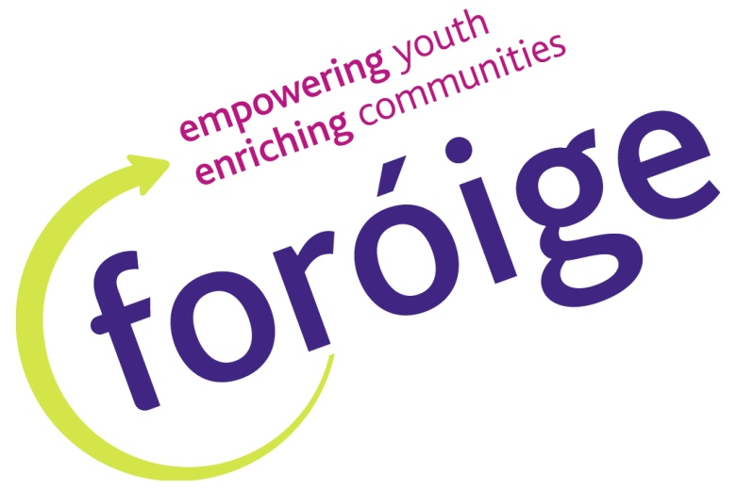

Report on the Foróige Reference Panel Conference panel Conference on the Irish Management Institute on the
21st – 23rd February 2014

Contents
Page
Executive Summary 3
Chapter I Conference Theme and Programme 5

Chapter II Exploring Self Image and What it Means 8

Chapter III What Young People Need to be Able
to Do Develop Positive Self Image 16

Chapter IV What Foróige Can Do to Help 18
Chapter V Response of the Head of Training
and the Youth Participation Officer 21

Executive Summary

- Introduction
This year’s Reference Panel held their first Conference on the 21st – 23rd February 2014 in the Irish Management Institute, Sandyford Co Dublin. After analysing the issues identified at the 14 Regional Conferences around the county it was decided that the most prominent issue that emerged was Positive Self Image. This became the theme of the conference. The Reference Panel focused on three questions
- What does positive self image mean to the Reference Panel?
- What do young people need to be able to do to develop a positive self image?
- How can Foróige enable young people to do this?

- What positive self image means to the Reference Panel
On discussing positive self image the following points emerged:
- It was hard to be your own person. There were strong social pressures that were keenly felt by young people.
- It was well worth the effort. A sense of your individuality was a great freedom to have and a great strength in life.
- It was crucial to value yourself and to practice doing this. Then you did not get trapped by comparison and fear of negativity or what others think
- There was a lot of negative influence out there so it was important not to let it get you down.
- You needed to be accepting of your limitations but not let them drag you down and to put more emphasis on your positive traits.

Overall the Reference Panel stated that positive self image meant:
- Being happy in yourself and comfortable in your own skin
- Finding your own path in life rather than following the crowd
- Being able to express your true self when with others
- Not being confined by negative pressures and put downs of others
- Accepting your limitations and flaws and focusing on positives

- What young people need to be able to do to develop a positive self image
Young people need to be able to:
- Find out what they love in life and like about themselves
- Believe in themselves, stand up for themselves and think as an individual
- Develop good social connections with others where they are affirmed
- Develop resilience in the face of negative social pressures
- Help others develop a positive self image

- How Foróige can help young people do this
Foróige clubs/groups
- Organise special activities that enable young people to develop a positive self image and sense of uniqueness (these are outlined in Chapter IV)
- Have more TAB Time where young people can express themselves and have their uniqueness respected and encouraged
- Develop a greater variety in club/group activities so that young people can discover and develop their unique talents
- Develop a club/group atmosphere and structure so that young people are safe and encouraged to be themselves and think for themselves (ideas in Chapter IV)

National Organisation
- Use social media to promote positive self image and positive peer influence. Keep posting positive information and messages on social media
- Organise another month like FAB Feb that focuses on developing self regard and positive self image e.g. Selfie September; Accepting April
- Develop leaflets on Positive Self Image, TAB Time etc. Organise T shirts where you can write positive messages
- Make a video on positive self image based on quotes discussed at Reference Panel Conference.
- Run the workshops on positive self image that were carried out at the Reference Panel Conference in clubs and in other groups
- Interview inspirational leaders (people who overcame adversity and developed inner strength) and put them on-line for young people to see
- Promote Albert Schweitzer Leadership for Life Programme
- Run sessions on positive self image at district council- guest speakers, TAB time etc
- Inter club events that focus on positive peer influence and positive self image
- Reference Panel to promote activities in club and district council that help young people develop positive self image.

Chapter I
Conference Theme and Programme

1.1 Introduction
This year’s Reference Panel held their first Conference on the 21st – 23rd of February 2014 in the Irish Management Institute, Sandyford, Co Dublin
The Reference Panel is a democratically elected body of Foróige members who make recommendations to the organisation’s National Council on issues effecting young people today. They also elect four of their members to the National Council of Foróige. 48 members were elected to the Reference Panel and all of these attended the Conference.
The Reference Panel Conference was run by Gerry Mc Donald Head of Training and Programmes and Sarah Haslam, Youth Participation Officer. The National Chairperson of Foróige, Paul Maher also attended and facilitated. Other volunteers who facilitated were Dave O’ Reilly Chillax Youth Cafe, Conor Hodgins Chillax Youth Cafe and member of the National Council and Executive, Stephen O’ Leary, Derrinturn Foróige club and member of the National Council and Executive, Michael Mc Kiernan, volunteer with Tallaght Youth Service, Davy Doyle Whitechurch Youth Development Project, Vanessa Mulhall volunteer with NFTE and Fiona Maher staff person, Tallaght Youth Service.

1.2 Main theme of the Conference
The Regional Conferences identified many issues which included peer pressure, pressures from social media, negative self image , pressures from advertising to look a certain way, mental health, motivation, body image. The central issue that emerged was the need to cultivate a positive self image particularly in the face of these pressures. This became the theme of the Reference Panel Conference.
Main Theme of Conference: Positive Self Image
The Conference focused on these questions.
Three questions were discussed over the weekend
- What does positive self image mean to the Reference Panel?
- What do young people need to be able to do to develop positive self image?
- How can Foróige enable young people to do this?
1.3 Conference Programme
Friday 21st February
- Opening of conference
- Exchange of Ideas and experiences on the benefits of Foróige
- Purpose and structure of Foróige
- Role of Reference Panel and National Conference
- Review of FAB Feb and Regional Conferences
- Programme for Conference

Saturday 22nd February

- Report on the Regional Conferences by Sarah Haslam
- Presentation on Uniqueness of Each Person by Gerry Mc Donald
- Workshop 1: What positive self image means to the Reference Panel
- Workshop 2: What young people need to be able to do to develop a positive self image
- Workshop 3: What Foróige can do to enable young people to do this
- Election to National Council and Youth Participation Committee

Sunday 23rd February

- Advocacy Plans for Regions
- Discussion with Seán Campbell CEO and Paul Maher National Chairperson of Foróige
- Photo shoot
- Home
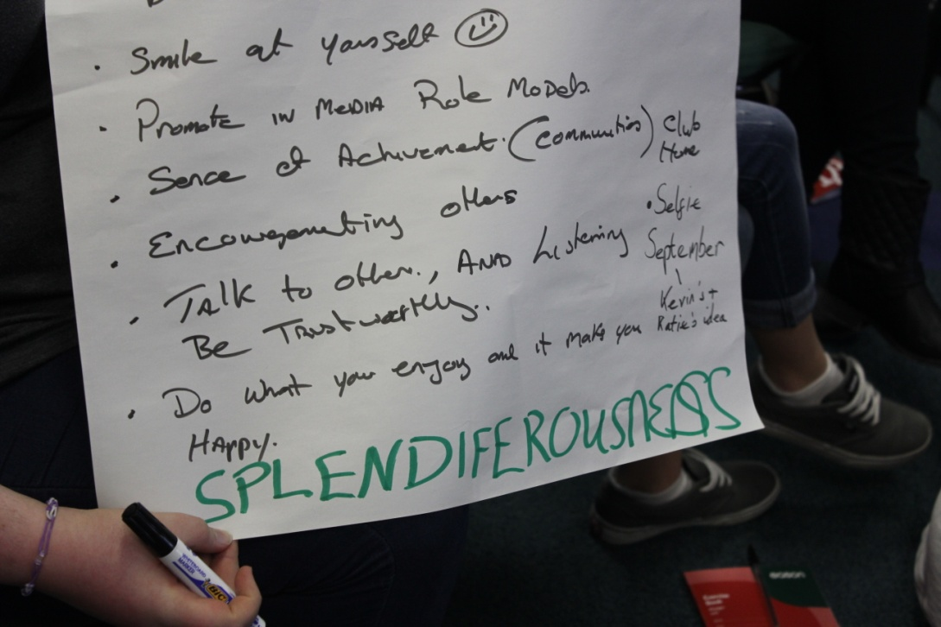
1.4 Issues Discussed on the Friday Night
FAB Feb
The Reference Panel made the following comments on FAB Feb
- Many more involved this year
- FAB Feb has a big effect on young people particularly on standing up for others
- TAB time is not strict and more laid back
- Should invite others to TAB time to have a chat
- Invite adults and guests to TAB time
- TAB time can be used to talk about issues of concern, to solve problems and generate ideas
- There can be a different topic every week or two
- There are still clubs that do not know about FAB Feb and TAB time. We heard about it at Regional Conferences

Regional Conferences

Best things about the Regional Conferences

- Meeting new friends; discussing problems/issues; hearing other people’s opinions; games; learning about Foróige; awareness of Issues, getting onto the Reference Panel; can voice opinions; food; good info to take back to clubs

How to encourage people to attend Regional Conference
- Show videos of how good it was; if people just knew what they were going to; explain how important it is and how young people can have voice; previous participants have a review; more advertisement on facebook/twitter;Show them what the Reference Panel has done in previous years; weekend conferences; have disco; full committee to attend.

Chapter II
Workshop I Exploring Self Image and What It Means
Two presentations were given in the Reference Panel:
- The issues identified at the Regional Conference and how the key theme that emerged was positive self image.
- The uniqueness of each person base on the philosophy of Foróige and its relevance to the issues identified at the Regional Conferences
The Reference Panel then divided into five groups to do three workshops over the day with staff and volunteer leaders as facilitators. In the first workshop the Reference Panel explored Positive Self Image and what it meant to them.
Section I; Discussing Quotes about Self Image

Posters were placed around the wall which displayed different quotes relevant to self image (See Appendix I). Each Reference Panel member reflected on these quotes and selected one quote that most stood out for them. They then discussed why they selected a particular quote and what it meant to them. This created a lot of reflection and discussion. The following are the quotes that had the biggest impact and what Reference Panel members said about them

Quote “The greatest prison people live in is the fear of what other people think”
This quote was probably the most frequent selection and many of the Reference Panel identified with it. They said that there was a fear of people mocking you or laughing at you behind your back. The problem could eat away at you. The group felt that it was very hard not to be intimidated by what other people think. It was hard to make a decision without making it about what everyone else thinks. However it was important to be true to yourself and do what you feel is right.
What Reference Panel members said about this quote:
“It has been very daunting for me going into a group not knowing anybody”
“In real life you feel like you are not free. You are not free if you worry about what people may think”
“The fear you experience is your perception of what other people think of you”
“I need to be more like myself not the person I think I should be -especially in school”
“You should try to make a decision based on what you feel and not based on what others think about you for the decision. Although this is hard it will pay off”

Quote “Don’t try so hard to fit in. You were born to stand out”
Many Reference Panel members selected this quote. They felt that there was big pressure to fit in and standing out could be hard. It was hard to do what you wanted and not be blocked by what the group thought. However if you could do it, it was very rewarding in the end. It was great to have a sense of your own individuality and uniqueness.
What Reference Panel members said about this quote
“This is hard! It is hard to do what you want and not be stopped by what others think -hard to do but very rewarding if you do it. Everyone tries so hard to fit in but they are not happy”
“Don’t change just because you don’t fit in. I didn’t want to be the one who followed the crowd. I eventually became my own person”
“It is about getting over my own barriers and realising I might as well have fun”
“I am an individual because I love who I am and don’t base who I am on what others want me to be. I love to sing, I love to cheer people up, I’m insane, I’m cuddly, I can write stories that would make you cry”
“I think Katie Taylor would be a good ambassador for positive self image because she did something that none of her friends did

Quote “If you know your own worth no one can make you feel worthless”
This quote was also a popular choice. Many Reference Panel members felt that having a sense of your own self worth was critical. If you valued yourself your were less influence by negative peer pressure and what others thought. You were not always comparing yourself to others

What Reference Panel members said in about this quote
“I chose my quote because I believe that no one can take who you are away from you. If you have your own feeling of self worth, people can say or do what they want to you, but they can never take away who I am”
“Without a good self image you can’t allow others to love you because if you don’t love yourself you cannot accept that love”
“Acknowledge who you are, be yourself and don’t be in fear of what anybody else thinks. It is what makes you that counts”
“Being positive with yourself image and accepting who you are doesn’t trap you in the fear of comparison by thinking you are any lesser than anyone else”

Quote “It’s not what you think you are that holds you back but what you think your are not”
Many Reference Panel members identified with this statement and felt that this was generally true. It is very easy to get caught up in what you lack instead of what you have. They felt that it was important to focus on your good qualities and not dwell too much on your flaws.

What Reference Panel members said about this quote.
“It is okay to have flaws and insecurities. It is not okay to let them define who you are and who you will be”
“Accept your weaknesses but don’t let them hold you back. Focus on your good qualities”
“It’s all too easy to get caught up in what you lack instead of what you have”
“Every day write down what you like and what you do well. Don’t focus too much on the negatives and don’t be afraid to try out new things”
“Your flaws are what make you human. Accept that imperfection is part of perfect”.
“Once you have accepted your “flaws”- when people point them out it will not have such an impact on you”

Quote “No one can put you down without your consent”
This quote was also selected by Reference Panel members. They felt it was important to be able to stand up for yourself and not let someone else’s negativity get “inside your head”. You could control your reactions to people and situations.
What Reference Panel members said about this quote
“To ensure that this quote happens I tell people that I don’t accept them making fun of me when they do. I either do this or I ignore them. This helps me stand up for myself and show people that I will not let them get me down”
“Don’t give negative people consent to get into your head. Don’t let bad opinions bring you down. You can be in control of your reactions”.
“If people try to make you feel bad they are not worth your friendship”
“I am the only person who can make me happy”

Main points from these discussions
Overall the main points of the discussion were:
- It was hard to be your own person. There were external pressures that were keenly felt by young people.
- However it was well worth the effort. A sense of your individuality was a great freedom to have and a great strength in life.
- It was critical to value yourself and to practice doing this. Then you did not get trapped by comparison and fear of negativity or what other think
- There was a lot of negative influence out there so it was important not let it get you down,
- You needed to be accepting of your limitations and flaws but not let these drag you down and put more emphasis on your positive traits.

Section II What Positive Self Image Means to the Reference Panel:

After these discussions each Reference Panel member wrote individually what positive self image meant to them. They were asked if they would be happy to share with us what they had written and to have it included in the report. They were happy with this. If anyone was not happy with this they could withhold what they had written. They discussed their ideas in the group. To summarise, the main points that emerged from this writing and discussion were:
Positive self image means:
- Being happy in yourself and comfortable in your own skin
- Finding your own path in life rather than following the crowd
- Being able to express your true self when with others
- Not being confined by negative pressures and put downs of others

Main points from these discussions
Overall the main points of the discussion were:
- It was hard to be your own person. There were external pressures that were keenly felt by young people.
- However it was well worth the effort. A sense of your individuality was a great freedom to have and a great strength in life.
- It was critical to value yourself and to practice doing this. Then you did not get trapped by comparison and fear of negativity or what other think
- There was a lot of negative influence out there so it was important not let it get you down,
- You needed to be accepting of your limitations and flaws but not let these drag you down and put more emphasis on your positive traits.

Section II What Positive Self Image Means to the Reference Panel:

After these discussions each Reference Panel member wrote individually what positive self image meant to them. They were asked if they would be happy to share with us what they had written and to have it included in the report. They were happy with this. If anyone was not happy with this they could withhold what they had written. They discussed their ideas in the group. To summarise, the main points that emerged from this writing and discussion were:
Positive self image means:
- Being happy in yourself and comfortable in your own skin
- Finding your own path in life rather than following the crowd
- Being able to express your true self when with others
- Not being confined by negative pressures and put downs of others
- Accepting your limitations and flaws and focusing on positives

The following are what Reference Panel members said about each of these themes
- Being happy in yourself and comfortable in your own skin
Reference Panel members said that this meant:

“Doing what you enjoy. Not doing things to impress others and fit in. Being independent
“Loving and accepting yourself for who are. It’s great to acknowledge who you are as a unique person in this world and not to be anyone else but yourself.
“Being happy most of the time with where/who/what you are and that the best you can be is yourself. Because if you aren’t yourself how can you expect other to accept the “not you”
“ Making sure I’m happy in myself, in what I do because everyone should be unique” “Euphoria -Immense feeling of happiness that no one’s actions or flaws or opinions can break”

- Finding your own path in life rather than following the crowd
Reference Panel members said that this meant:
“Not having to follow the crowd to be happy. Walking your own path in life”
“Believing yourself -that you are good enough and you are unique. It is trying to find yourself and not just following others- showing that you like who you are”
“Asking yourself: are you happy with your life, friends; are you happy with yourself? Being honest with yourself”
“Not confining yourself to a cage and rather letting yourself think outside the box”
“Having the confidence to try out things that are not usual”

- Being able to express your true self when with others
Reference Panel members said that this meant:
“Having the confidence to speak out openly and stand up for your opinions.
“Recognising who the real you is. Not comparing yourself to others and instead having confidence in yourself”
“Letting people see you for you and not someone else”
“Feeling happy about how you look and act around other people”
“Being able to express who you really are in front of people and not be intimidated by someone you think is better than you”
“Not worrying what others think and not changing yourself just to fit into the group”

- Not being confined by negative social pressures
Reference Panel members said that this meant:
“Not taking negative comments to heart”
“Not being afraid to speak up for yourself and others like you”
“Expressing myself and being who I want to be without fear of negative outside influences”
“Being happy with who YOU are and not who OTHER PEOPLE want you to be”
“Being happy and comfortable in myself and not having the opinions of others determining my worth and value”
“Not letting celebrities and TV make you feel small and pressure you to change”
- Acceptance of your limitations but focusing on your positive traits
Reference Panel members said that this meant:
“Being able to look at yourself and not pick out your flaws- rather pick out what there is to love about you”
“Being able to be positive and happy within yourself- being able to acknowledge your limitations but not let them drag you down”
“Accepting your flaws and imperfections but not letting them control you.
“Focusing on my strengths and not dwelling on my weaknesses”

Other comments from Reference Panel members:

Many other views and ideas came from this workshop. The following is a flavour of what else was said

A Positive Social Environment
“Sometimes I feel like I am not accepted by everyone and to have Foróige as a place where no one judges me is great. Here we can talk to one another and be ourselves”
“I love the way I can be myself around everyone here. They accept me for who I am”
“Surround yourself with people you love and people who love you and make you happy”

Uniqueness and normality
“If everyone was born the same where would all the craic be?”
“There is no definition for normal”
“I am unique. So why bother being like everyone else when I can be me and live my own life”
“You need to be unique because the world can be boring”
“Be a role model for others”

What do Avoid
“Don’t be a typical wanna-be of someone else”
“Do not always adhere to what is seen as normal”
“If you feel negative about yourself image, that is all you worry about and you won’t be able to enjoy yourself. Positive self image gives you less to worry about”.
“Don’t live just to impress others”
“Don’t let society mess you up”

Slogans written up by Reference Panel members during the weekend:

“Unique is the new normal”
“We are all unique but the same”
“Original is worth more than the copy”
“Make your own normal”

Other interesting points that came from the discussions:
- What positive self image is not
When the topic of positive self image was introduced in a group, one Reference Panel member exclaimed something like Errgghh! What motivated this was her initial view of positive self image as being painfully and boringly “full of yourself” with little regard for everyone else – a form of narcissism! This is a valid point but the Reference Panel members felt that this is not positive self image. It was not about being over cocky but being happy in yourself. After some discussion and exploration she wrote some excellent ideas on what positive self image can be which are included in this section.

- Uniqueness is a way of connecting with others
In a discussion with the CEO Sean Campbell, one Reference Panel member said that uniqueness not just about me on my own. It is not a self centred thing It is a way of being with others, You give your unique strengths to others and you respect and encourage their uniqueness.
- Positive self image and parents
In one group Reference Panel members said that parents can block you expressing your uniqueness by pressurising you to meet their expectations. A leader in the group is a parent and spoke on behalf of parents highlighting the worries they have about their children. After some debate it was felt that positive self image was expressing how you honestly felt in a respectful way while listening to their parent’s point of view and taking it seriously. It was about being able to have a proper dialogue with parents.

Group presentations
Group 1 presented a poster including images with the heading “be yourself because everyone else in taken”. They sang the song “I am what I am” They spoke about the importance of being yourself and presented the ideas discussed in the group
Group 2 sang the song “True Colours. The group then lowered their voices and hummed the tune when individuals read out pieces they had written about positive self image
Group 3 acted out a small drama about a young person being mocked and excluded by the group because she was wearing “uggs” shoes. One person goes against the group and stands up for her and states that “ I like uggs to be honest”. This stopped the negative taunting in its tracks and led to a more positive group dynamic.
Group 4 conducted a moving debate with the entire group using the following questions:
Are you happy with the environment in the school/home/Foróige?
Do you feel happy with yourself right now?
Have you ever let the judgement of others stop you from doing what you want to do?
These questions were discussed by the group
Group 5 printed the word uniqueness in separate letters. Individuals spoke on what uniqueness meant to them and the ideas that they discussed in their group

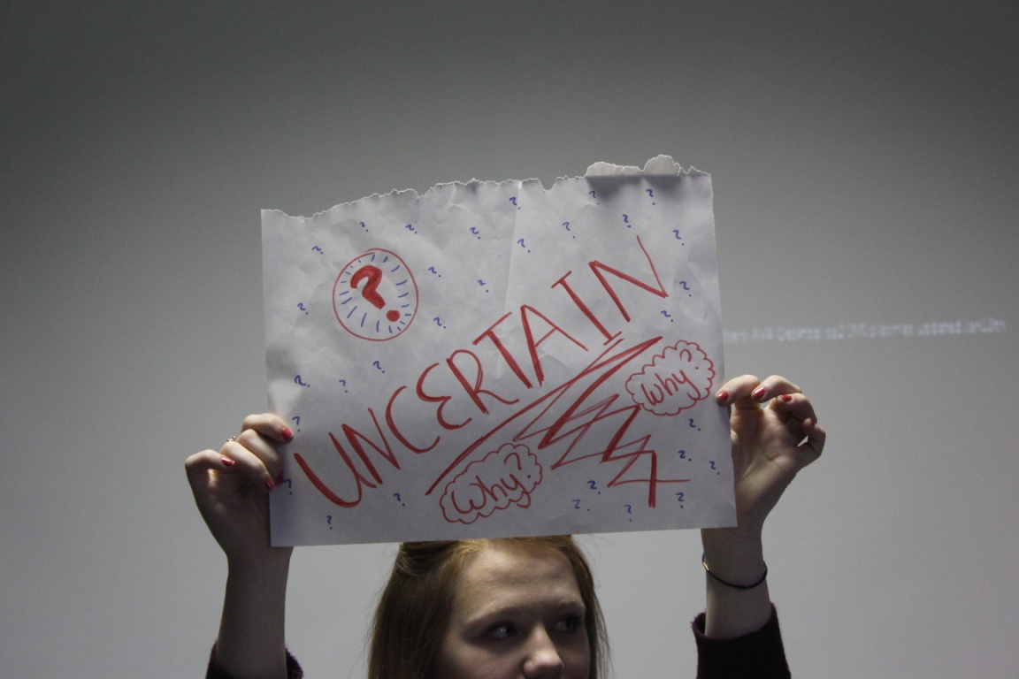

Chapter III
What Young People Need to be Able to Do to
Develop a Positive Self Image
In the second workshop The Reference Panel discussed what young people need to be able to develop a positive self image particularly in the face of negative social pressures. What they said can be summarised in the following five abilities.
Young people need to be able to
- Find out what they love in life and like about themselves
- Believe in themselves, stand up for themselves and think as an individual
- Develop good social connections with others where they are affirmed
- Develop resilience in the face of negative social pressures
- Help others develop a positive self image

The following is what Reference Panel members have said about these abilities

Able to find out what they love in life and like about themselves
- Find out what you enjoy and makes you happy and do this
- Find out what you like about yourself and develop this
- Embrace your talents and build on them
- Think about your hobbies – find ones that express your true self
- Don’t be afraid to find yourself – what you want to do. Find out who you are!

Able to believe in themselves, stand up for themselves and be true to themselves
- Recognise your strengths and accept your limitations.
- Focus on the positive in yourself. Don’t dwell on weaknesses or problems. Give yourself more credit
- Be honest with yourself. Stand up for what you believe and do what you feel is right
- Recognise that you are worth something. Don’t get caught up in comparing yourself negatively to others.
- Be trustworthy
- Don’t be afraid to fail!

Able to develop good social connections and connection to community
- Learn to accept yourself first. Then accept another’s difference. Stop pointing out people’s faults.
- Develop a good support system – friends, family, teachers, community
- Get actively involved in the community for achievement and recognition
- Surround yourself with positive people rather than those that put you down
- Engage in positive peer influence with others. Thorough workshops and TAB time learn to accept and be positive towards each other
- Have a positive role model –find a better role model if needed
- Be told what is good about you. Learn to accept compliments.

Able to develop resilience in the face of negative pressures
- Don’t let the bad opinions of others get you down
  - Do not take things too personal- be thick skinned
  - Don’t stoop to their level – not to react if the say something bad- see that you are then a better person- have more respect for yourself.
- Rise above negative comments. Find a way to turn negative experiences into a positive
- Find a healthy way to release frustrations –sports/exercise/ punchbag!
- Talk to friends, parents, siblings. Have someone to talk to who knows what it is like
- Take the advice you would give to a loved one
- Think for yourself. Do not adhere to what is perceived as normal.

Able to help others develop a positive self image
- Encourage others to develop their uniqueness and reach their potential
- Start with younger members. Show them their potential- encourage their strengths.
- Listen to the views of others and respect them
- Be kind to everyone because you don’t know what they have to deal with
- Don’t stereotype others. Welcome outsiders to the group
- Support others if they are down. If there are people on their own talk to them
- Prevent cliques forming and “bad vibes” being passed
- Get people to realise that what they are saying is hurtful
- Stand up for others as well as yourself

Chapter IV
What Foróige can do to Help?

5.1 What Foróige Club/Group Can Do

- Special activities that promote positive self image
The Reference Panel came up with a variety of events and practical activities that help young people to develop their uniqueness and self image. These included the following
- Everyone does a Fun Profile: -A3 poster about what you love, interests, goals etc. Do it every year and look back on it in five years to see how it has changed
- Have a “BE YOURSELF” night. (ABU night): Wear what you like. Express a particular talent. Talk about what you love; Games that get you talking about yourself; A no brands labels, make up night.
- Have a SHOW AND TELL night:- members speak about hobbies and interests they have and demonstrate. They involve others in their hobbies
- Have WORKSHOPS liked those done in the Reference Panel Conference- include fun games to help talk about a serious issue
- Each member gets a HEART with a positive message written about them.
- POSI CHARTS: A chart with your name and photo. Other right positive things about you on the chart
- BLACK AND WHITE T SHIRT positive compliments are written on it
- Every week write positive things about yourself
- Picture of you smiling in the mirror

- More TAB Time
Reference Panel advocated for more TAB time in more clubs/projects where young people could learn to express their true selves and appreciate the uniqueness of others.
- Members pick topics. Everyone expresses views
- Problem box – members put a concern into the box (anonymous) members pick a topic for discussion. Topics that are agreed by the group are discussed in TAB time
- Discuss self image in the club. Make it okay to talk about it. Use TAB time
- Have TAB time on the first night of the club so that everyone gets to know each other
- TAB time is a good channel of communication between leaders and members

- A variety of activities to suit different interests and talents
The club needs to create more opportunities where young people can discover and develop strengths, interests, talents
- A variety of different activities- not just the usual ones- where young people get opportunities to discover and express their strengths and talents
- Members use individual talents to help others
- Let members take control of activities and organise things
- Encourage young people to do the citizenship programme where they contribute to and get recognition from the community

- Continuing to Create a Positive Atmosphere in the club/group.
The Reference Panel felt that it was critically important for there to be a positive atmosphere where young people felt safe and encouraged to be themselves. The following were some ways of achieving this:
- Fun exercises/games where people get to express themselves and create positive self image. Have one big games that involves everyone
- A positive code of behaviour based on the Charter of Rights
- Have activities in the club where people mix and get to know each other better – this helps break up groups and cliques. Leaders participate to build relationships.
- Listen: Leaders and members listen to each other

5.2 What District Council can do?
- Bring the issue of positive self image to the District Council meetings to put on agenda
- Organise talks from guest speakers and experts on the topic of positive self image
- Organise inter club events/fun days based on the principles of positive peer influence
- Twin clubs and have TAB time together
- Invite guests to clubs/district council meetings and have TAB time with them
- Articles in local papers from PRO or different articles from young people on what Foróige means to them –presentations on local media/radio/word of mouth
- Make BBBS more widespread
- More counties take on ASLFL programme (Albert Schweitzer Leadership for Life)
- Have “Selfie September” month promote activities in clubs for example: selfies where everyone writes positive messages about you
- Reference panel- Make leaflets to give to DC so they know what we are doing.
- Foróige Fest - all attend
- Charity shop challenge: buy clothes for a small amount of money and have a fashion show

5.3 What the National Organisation Can Do
- Organise another month like FAB Feb that focuses on developing positive self image
- Example: “Selfie September”. Clubs do workshops and activities that promote positive self image – like activities done at Reference Conference
- Other ideas – “Accepting April”. “Just U2” June/July
- Develop leaflets on Positive Self Image, TAB Time, Positive Peer Influence for clubs/projects
- Use positive social media to promote positive self image and positive peer influence. Keep posting positive information on social media
- Make a video based on based on quotes used at Reference Panel Conference
- Teen Aware event for Foróige- event that is fun and helps young people become aware of issues.
- Interview inspirational leaders and put them on-line for young people to see
- Example: positive people who developed their inner strength and uniqueness in the face of adversity
- Promote ALSFL programme
- Unique Foróige Fashion Show
- Role model competition. One role model selected every week from young people in Foróige. There is an overall winner at the end of the year
- Competitions /interactions through facebook
- Organise T shirts where you can write positive messages

5.4 What the Reference Panel Can Do
- Promote activities in clubs and district council that help young people develop a positive self image
- Encourage TAB time in clubs and at district council
- Write leaflet for district councils on positive self image
- Make a video promoting positive self image
- Workshops we did at the Reference Panel Conference should be summarised and sent to all clubs- we can bring them back to clubs and run them with members
- Organise T Shirts where you could write positive messages.
- Promote self acceptance and positive self image among young people
- Organise instagram for “Selfie September”

Chapter V
Response of Head of Training and Youth Participation Officer
Last year’s Reference Panel report focused on young people’s interactions with each other which gave rise to the concept of positive peer influence now being used throughout Foróige.
This year’s report focuses on young people’s perception of themselves and what they can do to develop a positive self image. It focuses on how they can cultivate inner strength and a sense of their uniqueness. Both reports are important and mutually interdependent. They dovetail together as a process that not only to combats bullying and negative peer pressure but enables young people to achieve their best potential and wellbeing
The Reference Panel Conference have produced an excellent vision of what positive self image can be, what young people need to do to develop it and how Foróige can help. It is rich in insights as well as very practical ideas that can be done by any Foróige club/group
Developing a sense of Uniqueness and Inner Strength
Establishing a sense of their identity is a critical task of adolescence. It is clear from the report that the Reference Panel love the idea of their uniqueness and of having the freedom to be their true selves. Although they are acutely aware of the negative social pressures (and the pressures from within) that militate against this, it is what they truly want. Our job in Foróige is to help them get there. It is to help them to develop a strong sense of themselves and their freedom to become the person they want to be.
We need to continue and develop our work at creating positive environments for young people. However it is not possible to eliminate all negative influences and pressures. It is equally important that we enable young people to develop their inner strength and resilience, particularly in the face of these negative pressures. As the proverb goes “it is better to develop a good pair of slippers than to try and carpet the whole world”. The report indicates how we can continue to develop and improve upon our already successful process of doing both.
Positive Self Image is Social
One interesting point that the Reference Panel made is that positive self image is not just about you in isolation. Much of what the Reference Panel have said focuses on its social aspect. One Reference Panel member said that uniqueness was a way of being with others. It is no good if positive self image and uniqueness degenerate into narcissism and conceit. Rather, let it be something you exude that enhances the atmosphere and quality of life around you. It is a gift to others as well as to yourself. Uniqueness comes into its own when combined with your connection to others and the contribution to something bigger than yourself. This needs positive relationships to thrive. This integrates positive self image and positive peer influence. They work together to create a powerful process of human development in Foróige.
The Reference Panel are role models for what they advocate
The Reference Panel, along with the leaders and staff, were the great example of how the ideas of the conference are put into practice. What they talked about they did. The content of the conference became the process. They bonded together as a group and created this wonderful atmosphere because each brought their individuality and each encouraged and respected others as they are. As a result young people experienced directly a deep sense of their uniqueness as well as a deep connection with each other and with the leaders. As one Reference Panel member eloquently stated:
“Words would never describe how much the weekend did for me as a person. It made me feel that no matter what people do to you in life you are your own person and they can never take that away from you. The honesty and open mindedness of each person allowed us to be who we are. I did not have to be someone else to fit in. I felt so comfortable in my own skin. Leaving Dublin and going back to reality was difficult but now l had learned to love myself for who I am”
Conclusion
Overall the Reference Panel have developed powerful concepts of positive self image that are essential for young people and for our work in Foróige. These concepts as well as positive peer influence should be our driving force. We are doing this very well already but with some reflection and study of this report we can discover great opportunities for doing it better.
For example when analysing a club/group it is good to ask:
How well do we enable young people to develop the five abilities outlined in Chapter III? What do we do well? What more can we do?
Chapter IV also outlines very practical activities that can be done by any Foróige club or group. These ideas could be put into a booklet for use by clubs/groups
The depth of insight and wealth of wisdom developed by the Reference Panel never fails to impress. It is always amazing what they create while having great fun at the same time. Reading the report can have a healing effect on us all - more so than those many and expensive self help books! If the very practical ideas in the report are put in the practice in Foróige clubs/groups then more and more young people will have experiences similar to the Reference Panel.

Appendix I

In the first workshop the following quotes related to self image were displayed on posters. Young people selected one quote that most stood out for them and discussed what it meant to them. This gave rise to much discussion and many good insights.

Poster 1
“The greatest prison people live in is the fear of what other people think”

Poster 2
“To be yourself in a world
that is constantly trying
to make you something
else is the greatest
accomplishment”

Poster 3
“Don’t try so hard to
fit in. You were born
to stand out”

Poster 4
“If you know your
own worth no one
can make you feel
worthless”

Poster 5
“Don’t let
comparison
steal your joy”

Poster 6
“It’s not what you think
you are that holds you
back but what you
think your are not”

Poster 7
“No one puts you down without your consent”

Poster 8
“Talk to yourself like
you talk to someone
you love”

Appendix II
Songs were an important part of this conference Throughout the Conference a number of pop songs emerged whose lyric were very relevant to the topic. There were sung by the Reference Panel at different times. They added to the atmosphere of the conference and got everyone relaxed and involved. The highest point was when the group stood up on the chairs and sang “Express Yourself”.
Express Yourself
I say the same thing twice, I’m awkward when I speak
Ain’t got the perfect smile, don’t turn heads on my street
Trying to be a superstar like everybody else
But being myself is something I do well
Whatever you do do it good
Whatever you do do it good
Express yourself
Express yourself
See it’s not what you look like
when you’re doing what you are doing
Express yourself
Express yourself

I am what I am
I don’t want praise I don’t want pity
I bang my own drum
Some think it’s noise I think it’s pretty
And so what if I love each sparkle and each bangle
Why not see things from a different angle
Your life is a shame
Do you can shout out I am what I am
Do you can Shout out I am what I am
I am what I am
And what I am needs no excuses
I deal my own deck
Sometimes the aces sometimes the deuces
It’s one life and there’s no return and no deposit
ON life so it’s time to open up the closet
Life’s not worth a damn till you can shout
I am what I am

True Colours

You with the sad eyes
Don’t be discouraged
Oh I realise
It’s hard to take courage

In a world full of people
You can lose sight of it all
And the darkness there inside you
Makes you feel so small

But I see your true colours
Shining true
True colours
Are beautiful like a rainbow

If this world makes you crazy
And you’ve taken all you can bear
Just call me up
Because you know I’ll be there

Don’t be afraid to let them show
Your true colours
Your true colours

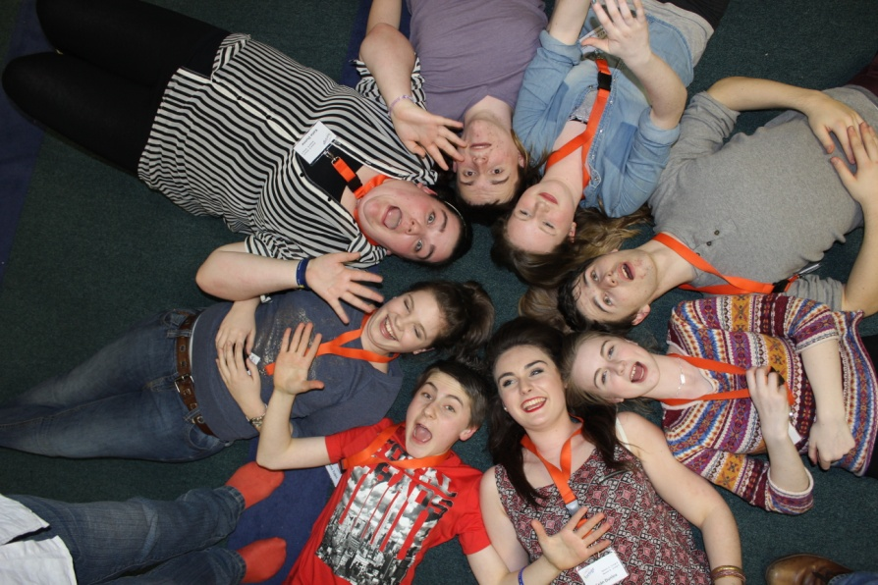

REFERENCE PANEL MEMBERS ELECTED JANUARY 2014

1. Caoimhe Hodgins – Chillax Youth Café, Co. Wicklow

2. Rebecca Kearney – Bunclody Foróige Club, Co. Wexford

3. Lauren Lehane – Castle Foróige Club, Co. Cork

4. Aishling O’Keeffe – Banteer Foróige Club, Co. Cork

5. Denis O’Sullivan – Whitechurch Foróige Club, Co. Cork

6. Kirsty Hayes – Clonakilty Foróige Club, Co. Cork

7. Fiona Tobin – Ardfield/Rathbarry Foróige Club, Co. Cork

8. Ronan Lehane – Churchtown Foróige Club, Co. Cork

9. James Byrne – Milltown Foróige Club, Co. Kildare

10. Shaunagh Dunne – Daredevil Foróige Club, Co. Laois

11. Ciana Cooney – Bullaun Foróige Club, Co. Galway

12. Eric Maloney – Kilconly Foróige Club, Co. Galway

13. Dara Brennan – Monivea Foróige Club, Co. Galway

14. Katie Coughlan – Carrabane Foróige Club, Co. Galway

15. Aisling Byrne – Rathvilly Foróige Club, Co. Carlow

16. Aaron Colfer – Rathvilly Foróige Club, Co. Carlow

17. Sean Devers – Ardagh Foróige Club, Co. Mayo

18. Adrienne Walsh – Fayz Foróige Club, Co. Mayo

19. Laura Whelton – Knock Foróige Club, Co. Mayo

20. Alisha Houlihan – Fayz Foróige Club, Co. Mayo
21. Grace Winters – Cong Foróige Club, Co. Mayo

22. Ben Thornton – Athea Foróige Club, co. Limerick

23. Ericka Daly – Newcastlewest Foróige Club, Co. Limerick

24. Hannah McColgan – Carndonagh Foróige Club, Co. Donegal

25. Ciara Crawford – Frosses Foróige Club, Co. Donegal

26. Cormac Whelan – Carrigallen Foróige Club, Co. Leitrim

27. Mark Farrell – Grange Foróige Club, Co. Sligo

28. Liam Roddy – Grange Foróige Club, Co. Sligo

29. Nuala Landers – Ballyduff Upper Foróige Club, Co. Waterford

30. Sean Kennedy – Lismore Foróige Club, Co. Waterford

31. Eoin Byrne – S.T.T.P. Youth Café Walkinstown, Co. Dublin

32. Zoe Koulianou – The Hot Spot Foróige Club, Co. Dublin

33. Balakis Falade – The Hot Spot Foróige Club, Co. Dublin

34. Jack Woolley – M.C. Teens Foróige Club, Co. Dublin

35. Katie Dunne – Tallaghtfornia Foróige Club, Co. Dublin

36. Kevin Daly – Tallaghtfornia Foróige Club, Co. Dublin

37. Daniel Thompson – Kileevan/Newbliss Foróige Club, Co. Monaghan

38. Sarah Doonan – Corlough Foróige Club, Co. Leitrim

39. Sean Dunlea – Drumraney Foróige Club, Co. Westmeath

40. Natalie Ward – Coralstown Foróige Club, Co. Westmeath

41. Abbigail Hannevig – Durrow Foróige Club, Co. Westmeth

42. Kevin O’Flaherty – CSI Foróige Club, Co. Westmeath

43. Ava McManus – Drum Foróige Club, Co. Roscommon

44. Kevin Seery – Drum Foróige Club, Co. Roscommon

45. Saskia Kirrane – Cloonfad Foróige Club, Co. Mayo

46. Kelly Rennick – Oldcastle Foróige Club, Co. Cavan

47. Caoimhe Heeney – Duleek Foróige Club, Co. Meath.

48. Martynas Mickericus – Duleek Foróige Club, Co. Meath
16, The Willows, Duleek, Co. Meath. Mobile: 087-4115130

