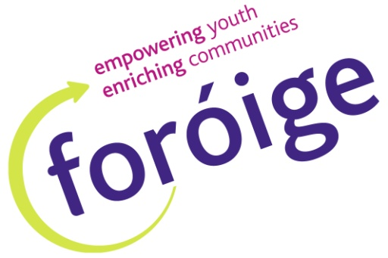

Balloon Games



**Balloon Pop Relay**

Form children into two lines facing a bag of balloons about 20 feet away. At the starting signal, children must race to the balloon bag, take one out and pop it as quickly as possible by sitting on it, stepping on it, or any other means. They then race back and tag the next team member in their line. The first team to have every player pop a balloon is the winner.



**Googly Balloons**

Blow up balloons, putting a small marble through the neck of each one before tying the end. This makes the balloons move in unexpected ways. Release into the group one more balloon than children. The object is to keep the balloons up in the air. Play this in two teams, each side with an extra balloon. The team who lets a balloon drop to the floor first loses.

**Catch the Balloon**

Gather children in a circle around the adult leader. Toss a balloon in the air and call one child's name. That child must catch the balloon before it touches the ground. If the child succeeds, she/he gets to toss the balloon and call the next name.



**Balloon Bop**

Form children into a circle with an adult leader in the middle with a balloon. Each child will have a chance to hit the balloon to keep it up, but here's the catch. The leader will call out the person's name and a body part, and they must use that body part to hit the balloon upwards to keep it in play. You can use hands, feet, knee, elbow, head, and hips or butt. Players who use the wrong body part or let the balloon fall to the ground are out. The last player standing with the balloon in play is the winner.

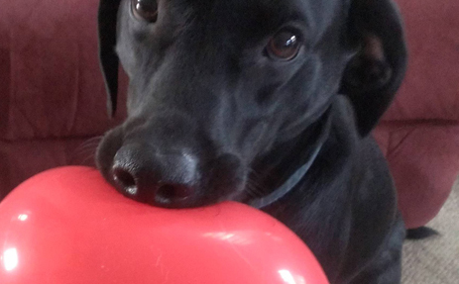

**Balloon Balance**

Blow up about 10-15 balloons and place them on the floor. Each child has 2 minutes (use a timer) to pick up and hold as many balloons as possible. They must pick up the balloons all by themselves without any help- put them in their clothes, between their legs, under their arms, between their teeth, etc. Each guest takes a turn while the others watch.The child who holds the most balloons when their time is up is the winner.

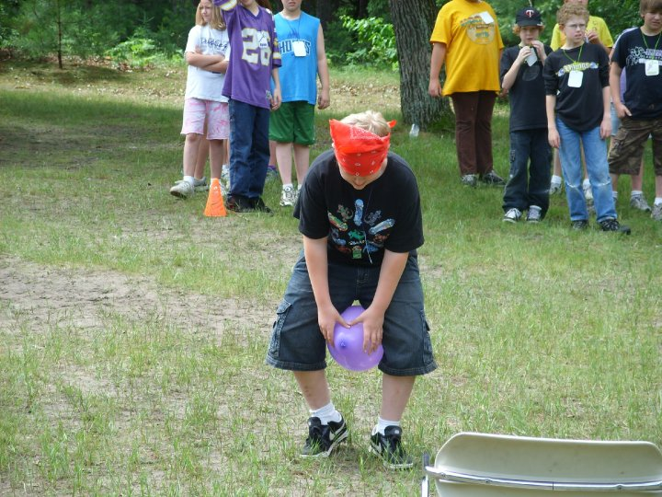

**Balloon Relay Race**

Instruct the group to stand in two single-file lines, facing forward. Place a balloon between the knees of the first child in each line. When the race starts, the first child on each team turns to face the next person in line. The second child must grasp the balloon with his or her knees and turn to pass it on to the third person, and so on. If the balloon falls to the ground, the team must start over. The first team to successfully pass the balloon down the line wins!

**Round Up the Herd**

For this game you will need two brooms, a long string to mark your course, six balloons (and

a few extra in case any should pop). Set up an obstacle course in your outdoor area using boxes, chairs, bushes, trees, etc. Mark the path of your obstacle course with string. Divide children into two teams and line up both teams at the starting line. Give the first person in each line a broom and three balloons. (Be sure to use different coloured balloons for each team). They must use the broom to herd their wild ponies (balloons) through the course. Each player must herd their balloons through the entire course to complete their turn. The first team to finish the course wins! If a balloon pops during a player's turn, he or she must take a new balloon to the starting line and begin again.



**Balloon Favours**

Insert a small sticker (with prizes to collect at end of game i.e. sweet, pencil, ball) into the opening of a balloon before inflating it. Then, inflate the balloon and repeat until you have a balloon for each guest. Use these balloons to decorate the games area. At the end each guest

may take a balloon and pop it by sitting on it, kicking it, etc. to get the prize hidden inside.



**Balloon Pop**

Place notes inside un-inflated balloons, one or two of the notes should indicate that this balloon is a winner. Inflate the balloons and hang them around. Let each child pick a balloon then pop it to see if their note is a winner.



**Floating Balloons**

Blow up and pass a large balloon to each child. Let them blow up their balloon and offer your help tying each one securely. The object of this game is to hit the balloons up into the air and keep them afloat for the longest period of time.