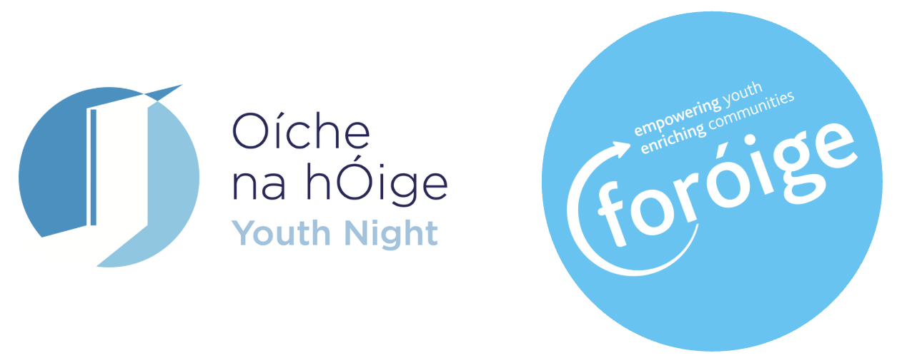
Sample Post-Event Press Release
(For local adaptation - please update details before sending to local media)

FOR IMMEDIATE RELEASE
Date: [Insert date after event]

Local Young People Take Centre Stage for Foróige Youth Night 2026
[Town/Area], [County] – There was plenty to celebrate in [Town/Area] as young people from [Foróige Club/Project Name] opened their doors to the local community for Oíche na hÓige / Youth Night 2026 on [insert date].
Families, friends and neighbours were invited to experience Foróige first-hand, meet the young people involved and discover the activities, friendships and opportunities that make their local Club/Project such an important part of the community.
The event featured [briefly describe activities, e.g. music, games, performances, exhibitions, displays or refreshments], giving young people an opportunity to share their talents, celebrate their achievements and show visitors what Foróige is all about.
[Insert name], [role] with [Club/Project Name], said:
“Youth Night was a fantastic opportunity to bring everyone together and celebrate our young people. We're incredibly proud of everything they do, and it was brilliant to see them sharing their experiences and showing the community what makes our Club/Project so special.”
The celebrations also recognised the dedication of Foróige's adult volunteers, whose time and commitment help create welcoming spaces where young people can make friends, develop new skills, build confidence and take an active role in their communities.
Oíche na hÓige / Youth Night 2026 takes place on Friday, 13 November, with Foróige Clubs and Projects across Ireland hosting events and activities around the date. The nationwide celebration highlights the positive impact of youth work and the contribution young people and volunteers make to communities throughout Ireland.
Youth Night 2026 is supported by the Department of Education and Youth and local Education and Training Boards (ETBs).
For more information, contact:
[Club/Project contact name]
Email: [email address]
Phone: [phone number]

Ends
Organised by Foróige Clubs and Projects nationwide as part of Oíche na hÓige / Youth Night 2025, supported by the Department of Education and Youth and local Education and Training Boards.
About Foróige
Foróige is Ireland’s national youth development organisation. We work with over 50,000 young people aged 10–24 each year through Clubs, Projects and Programmes, supported by more than 5,000 volunteers. Our purpose is to enable young people to involve themselves consciously and actively in their own development and in the development of society.
For more information, visit www.foroige.ie or follow @foroige on social media.

