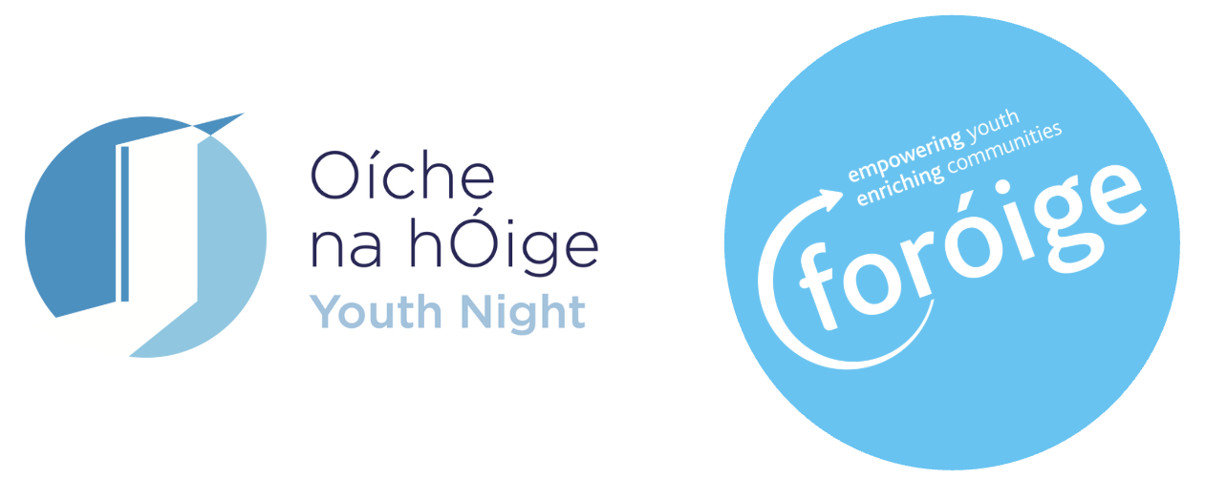
Sample Post-Event Press Release
(For local adaptation - please update details in red before sending to local media)

FOR IMMEDIATE RELEASE
Date: [Insert date after event]
Foróige Club in [Town/Area] Celebrates Youth Night 2025
[Town/Area], [County] - Young people from [Foróige Club/Project Name] welcomed parents, neighbours, and local representatives to their Oíche na hÓige / Youth Night event on [insert date], celebrating the creativity, confidence, and community spirit that Foróige young people bring to the area.
The event - part of Youth Night 2025, a national celebration of youth work - showcased the projects, performances, and achievements of local Foróige members. Guests enjoyed [briefly describe – e.g. music, exhibitions, displays, or refreshments], and heard directly from young people about what being part of Foróige means to them.
[Insert name], Chairperson of [Club Name], said:
“Our Youth Night was a brilliant way to show the difference Foróige makes - giving young people space to lead, connect, and make a real impact in their community.” [Update sample quote]
The evening was also a chance to thank the adult volunteers and supporters who make Foróige’s work possible.
Youth Night 2025 was supported by the Department of Education and Youth and local Education and Training Boards (ETBs), with Foróige Clubs and projects across Ireland taking part throughout the week of 21–28 November.
For more information, contact:
[Club contact name]
Email: [email address]
Phone: [phone number]

Ends
Organised by Foróige Clubs and Projects nationwide as part of Oíche na hÓige / Youth Night 2025, supported by the Department of Education and Youth and local Education and Training Boards.
About Foróige
Foróige is Ireland’s national youth development organisation. We work with over 50,000 young people aged 10–24 each year through Clubs, Projects and Programmes, supported by more than 5,000 volunteers. Our purpose is to enable young people to involve themselves consciously and actively in their own development and in the development of society.
For more information, visit www.foroige.ie or follow @foroige on social media.

