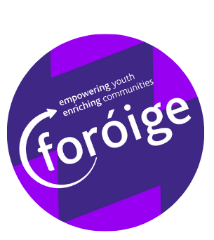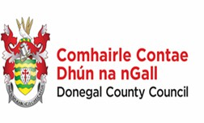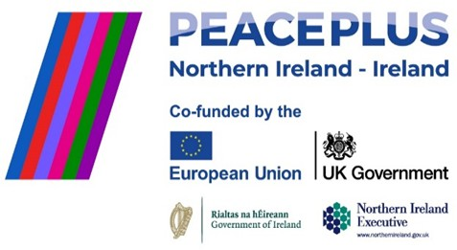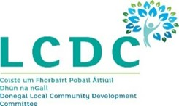

Donegal Peace Respectful Relations Project
JOB DESCRIPTION

JOB TITLE: Project Worker
PROJECT: Donegal Peace Respectful Relations Project
LOCATION: South Donegal base-with outreach to other areas
HOURS: 1 x Part Time Post 17.5 HRS MINIMUM- Ongoing Contract Subject to funding, (to June 2027)
ANNUAL LEAVE: 29 DAYS (PRO RATA-BASED ON FULL TIME POST)

ABOUT FORÓIGE
Foróige is an independent, non-profit national voluntary youth organisation engaged in out-of-school youth development and education. The organisation aims to enable young people to involve themselves consciously and actively in their own development and the development of society. Foróige employs over 600 staff and involves thousands of volunteers in the creation and delivery of highquality services to young people through the operation of over 600 Foróige Clubs and over 140 General Youth Services and Special Projects. These community-based and community-supported initiatives are run throughout the country, in rural and urban environments, and generally in partnership with various voluntary and statutory agencies. The organisation is a registered charity and is supported by a combination of statutory, philanthropic and corporate funding. Foróige is an equal opportunity employer and is committed to a policy of Equality of Opportunity in its employment practices.

Respectful Relations Youth Programme

The Respectful Relations programme from June 2025 to June 2027 will focus on behavioral change as an aspect of building relations between people from different backgrounds, including under-represented groups to develop young people’s social, emotional, and positive relationship skills. Through engagement with public agencies including those within An Garda Síochána, HSE, youth development organisations, community and schooling, the programme should explore training and knowledge enhancement sessions, aimed at enhancing the capacity of young people, to form positive and effective relationships with others of a different background, and make a positive contribution to building a cohesive society.
The programme may explore several relevant subject areas including diversity, gender, boundaries, personal development, sexuality, consent, the law pertaining to child welfare and protection, social norms & values, recognition and communications, accessing supports, self-esteem, taking and distribution of offensive images, mental & physical health, and/or other relevant programme topics

deemed appropriate, by allowing participants the opportunity for social and emotional learning, in a supported, non-judgemental and safe environment.
The programme will seek to encourage more respectful relationships, between targeted groups and key institutions, recognising the two-way process involved. The programme will seek to engage with key stakeholders to discuss needs, issues, priority areas and key interventions that are based on respectful relationships and behaviours that will feed into programme delivery.
The programmes will use innovative learning techniques including mentoring, group facilitation sessions, site visits, and training events, and incorporate a cross border element as part of programme delivery.
This personal development programme encourages positive enhancing behaviour traits, and provides participants with skills, knowledge, and confidence to develop healthy and respectful relationships which they can carry forward through their adolescents and beyond.
The desired outcomes of the Peace programme would be aligned to the National Policy Framework for Children and Young people 2023-2028, the Children and Young Peoples CYPSC plan for Donegal and the Donegal Local Economic and Community Plan, Healthy Ireland Strategic Action Plan.

KEY RESPONSIBILITIES
The successful candidate will be employed by Foróige and will be given a contract of employment. It must be understood however, that if the position becomes redundant at any time during the period of the contract or if the funding for the post is discontinued or a post holder fails to perform satisfactorily, employment may be terminated.

The duties of the Respectful Relations Project workers in carrying out any functions, which may be involved in or arise out of the appointment shall be as notified by the board of Foróige and/or its Chief Executive Officer and/or the nominee of the Chief Executive Officer from time to time. These duties will include but are not limited to the following;
- Design and deliver Respectful Relationships countywide youth Peace Programme for 10-18 year olds.
- Host launch and closing celebration events, with a minimum of two press releases.
- Collaboration with relevant community organisations and public agencies.
- Provide clear peace and reconciliation content included in the development of the Programme that builds capacity, promotes social inclusion, breaks down barriers and creates bridges and lasting relationships between communities on a cross community /border basis.
- Provide a detailed methodology and timeframe of programme delivery, activities, workshops, visits, events etc accompanied with defined specific participant objectives, result indicators, output indicators, and how these will be achieved.
- Provide clear detail of activities and actions required to operationalise the Programme.
- Provide details of monitoring & evaluation techniques employed before, during and after programme implementation and delivery.
- Give due consideration to the EU Core Sustainable Horizontal Principles, and Charter of Fundamental Rights.
- Outline publicity strategies in line with the SEUPB Publicity Guidelines regarding production of articles, press releases, social media posts, production of visual communications and digital content.
- Any such other relevant duties as the board of Foróige and/or the Chief Executive Officer or the nominee of the Chief Executive shall deem necessary for the effective implementation of Foróige's policy and programmes

PROFESSIONAL QUALIFICATIONS AND EXPERIENCE (E) = Essential, (D) = Desirable
- Education to National Diploma or Degree standard preferably in Youth / Community Work (note: candidates with exceptional, relevant work experience may also be considered in lieu of degree qualifications) (E)
- A minimum of 1 year relevant work experience (D)
- Access to car and full driving licence (E)
- Ability to engage target group (E)
- Paid or voluntary, experience working with young people (D)
- An understanding of Youth Work and Community Work methodologies (D)

PERSON SPECIFICATION (all Essential requirements)
- Ability to build and maintain effective relationships with young people
- Good interpersonal skills, including ability to liaise with a wide range of contacts and build and maintain effective working relationships
- Excellent standards of accuracy and attention to detail
- Ability to be proactive, use own initiative and work effectively within a pressurised environment
- Positive and flexible approach to working as part of a team
- Good written communications skills, including ability to draft summary information and correspondence, good report writing skills.
- Ability to follow organisational guidelines and processes.
- Good computer skills, including Word, Excel, Internet, PowerPoint and Social Media

REQUIREMENTS OF ALL FORÓIGE STAFF (all Essential requirements)
- Commitment to the purpose of Foróige and to work within the values, policies and procedures of the organisation
- To act consistently in a professional manner at all times
- To participate in regular supervision with your line manager
- Flexibility in relation to hours of work to meet the needs of the work. Work during unsocial hours may be required.
- Identify training needs with your line manager and participate in training opportunities appropriate to the role
- To undertake other duties as may be requested by the board of Foróige and /or the Chief Executive Officer of Foróige or their nominee from time to time

ADDITIONAL CONSIDERATIONS FOR THE ROLE

Funding: It must be understood that if the funding for the post is discontinued the post holder’s contract may be terminated.

Garda vetting: As our work involves contact with young people, candidates under consideration for employment in Foróige will be subject to Garda vetting.

References: The successful candidate will undergo 2 reference checks before commencing employment with Foróige.

Annual Leave: The Youth Officer will be entitled to 29 days annual leave pro rata plus public holidays, this is based on a 35 hour contract and will be adjusted according for this part time post. The needs of the job must be considered when applying to take this leave.

Hours of work: The Part Time Youth Officer will be expected to work a minimum of 17.5 hours per week. Please note this position will require flexibility in relation to working hours. It is expected that the Youth Officer will work some late evenings (up to 11pm) and some weekend work.

Salary: The salary for this position will be based on the Youth Officer salary scale below

€37,436, €38,994, €40,552, €42,113, €43,671, €45,235, €46,798, €49,127,
€51,457

Travel: This post will involve some domestic travel within Ireland and occasional meetings. Travel and expenses will be paid in accordance with appropriate Foróige rates.
Base: The employment base for this role will be Donegal (exact location to be confirmed upon appointment).
Applications: Please apply by Foróige application form here.

